**AN EVALUATION OF Negative Human PERCEPTIONS OF Robots**

**By**

**Jalena Jones**

**A Proposal Submitted in Partial Fulfillment of the Requirements**

**For the Degree of Bachelor of Science in The**

**Department of Mathematics and Computer Science**

**Claflin University**

**Orangeburg, South Carolina**

**October 2022**

|  |  |  |
| --- | --- | --- |
|  |  | *Ramaier Sriram 10/14/2022* |
| **Dr. Karina Liles** |  | **Dr. Ramaier Sriram** |
| **Thesis Advisor** |  | **Committee Member** |
| Text  Description automatically generated with medium confidence10/15/2022 |  |  |
| **Dr. Srikant Pawar** |  | **Dr. Karina Liles** |
| **Committee Member** |  | **Academic Advisor** |

|  |  |  |  |
| --- | --- | --- | --- |
| **Received by:** |  | **Date:** |  |
| **Dr. Karina Liles, Chairperson, Department of Mathematics and Computer Science** | | | |
| **Received by:** |  | **Date:** |  |
| **Dr. Verlie Tisdale, Acting Dean, School of Natural Sciences and Mathematics** | | | |
| **Received by:** |  | **Date:** |  |
| **Dr. Verlie Tisdale, Interim Vice Provost for Academic Affairs** | | | |

**ACKNOWLEDGEMENTS**

I wish to thank my professors, advisors, committee members, and supporters for providing me with the necessary tools to continue and complete this study.

**PROBLEM STATEMENT**

Scientists are continuously finding more innovative ways to incorporate Artificial Intelligence and Robotics into the daily lives of people. Robots have been created to do a number of tasks such as assisting with the education of children [2] to emergency evacuation procedures in buildings [4]. However, there are many who are not waiting with open arms to welcome this technology in such intimate parts of their lives. It is important to examine these concerns and bridge the gap between the trust of humans and the functions and capabilities of robots. This paper was composed using the comparison of two evaluations [15,17] that incorporated the *Negative Attitudes Toward Robots Scale (NARS).*

**PROPOSAL SUMMARY**

Advancements in technology are increasing at an alarming rate, especially in the field of Human Computer Interaction (HCI). This increased rate in technological advancements, in turn, causes an increased demand for those with the knowledge to continue said advancements. Robotics and devices integrated with Artificial Intelligence are being incorporated into classrooms as well, but the effect of these non-human educators must still be further evaluated. We propose a study of the evaluation of several methods that examine human perceptions of robots through the *Negative Attitudes Toward Robots Scale (NARS).*

**KEYWORDS AND ABBREVIATIONS**

Keywords:

* Human Computer Interaction
* Robotics
* Negative Attitudes Towards Robots Scale

Abbreviations

* HCI - Human Computer Interaction
* NARS - Negative Attitudes Towards Robots Scale

**LIST OF TABLES**

**No table of figures entries found.**

**LIST OF FIGURES**

Figure 3. Study 1: Mean differences in trusting beliefs and trusting intentions....13

Figure 4. Study 2: Mean differences in trusting beliefs and trusting intentions....14

**TABLE OF CONTENTS**

**ACKNOWLEDGEMENTS** ii

**PROBLEM STATEMENT** iii

**PROPOSAL SUMMARY** iv

**KEYWORDS AND ABBREVIATIONS** v

**LIST OF TABLES** vi

**LIST OF FIGURES** vii

**TABLE OF CONTENTS** viii

**INTRODUCTION** 1

Background of the Study 1

Purpose of the Study 1

Research Question(s) and Hypotheses 2

Summary 2

**LITERATURE REVIEW** 3

Summary and Conclusions 3

**METHODOLOGY** 4

Population 4

Sampling and Sampling Procedures 4

Data Collection Procedures 4

Instrumentation (if applicable) 5

Data Analysis Plan 5

Limitations 6

Ethical Procedures 6

Summary 7

**DISCUSSION AND CONCLUSIONS** 8

Discussion 8

Recommendations 8

Conclusions 9

**REFERENCES** 10

**Appendix A: Title of Appendix** 11

**INTRODUCTION**

Robotics and Artificial Intelligence have created much excitement in the world. Human-Robot Interaction (HRI) has recently received considerable attention in the academic community, in labs, in technology companies, and through the media according to Goodrich et al. in the article “Human–Robot Interaction: A Survey”. They have been incorporated in a variety of settings such as restaurants, homes, vehicles and schools. In a learning session a student might remember the lesson from a robot more than they would if it had been delivered at school by their human teacher (Amanda J. C. Sharkey, 2016). Human-Robot Interaction (HRI) has also recently received considerable attention in the academic community, in labs, in technology companies, and through the media according to Goodrich et al. in the article “Human–Robot Interaction: A Survey”. However, there is still apprehension toward the incorporation of robots into the daily lives of users. Due to the increasing presence of robots and vessels of artificial intelligence in the lives of humans, it is important to understand this apprehension and consider methods to create a more harmonious cohabitation of humans and robots.

Purpose of the Study

The goal of this research is to evaluate negative human perceptions using the Negative Attitudes Towards Robots Scale (NARS) and consider methods to alleviate user concerns and apprehensions about robots. Two studies that use the NARS scale in their experiments will be compared. Each of these studies requires participants to interact with robots that perform specified tasks. Participants observe the robot as they complete these tasks and complete questionnaires that encourage the participants to reflect on their experiences.

Research Question(s) and Hypotheses

Will participants feel more comfortable around a robot that performs simple tasks with minimal interaction, such as handing an item to the human? Will participants trust a robot enough to allow for autonomy in more complex tasks such as driving? The possible results are an initial uneasiness toward the interaction with the robots with participant concern increasing with increased proximity of the task. The greater the risk of the task, the less inclined the participant is to trust the robot. Also, participants may prefer a more human-like (in appearance or mannerisms) robot, compared to more traditionally built robots.

**LITERATURE REVIEW**

**Robots at Home**

The NARS was developed using a lexical method. In this study, the researchers created a scale based on free-form responses from participants regarding anxieties towards robots [16]. Table 1 [15] describes the NARS Items that were presented to users in the experiment conducted by Syrdal, et al. These items were also assigned sub-scales. The sub-scales are as follows:

**Sub-scale 1: Negative Attitudes toward Situations and Interactions with Robots**

**Sub-scale 2: Negative Attitudes toward Social Influence of Robots,**

**Sub-scale 3: Negative Attitudes toward Emotions in Interaction with Robots.**

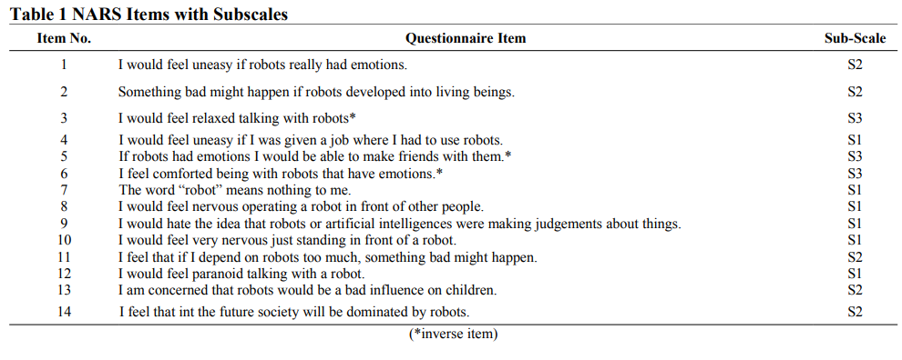

=

In the experiment, twenty-eight participants between the ages of 18-55 were asked to take part in a simulated “living room” to complete a task in a shared space with a robot. The robot's behavior would differ between the two sessions. These pre-determined behaviors were labelled Socially Ignorant and Socially Interactive. Following each interaction, participants evaluated the robot’s behavior and rate the robot’s personality on a scale. Following the researchers’ compilation of the results of the NARS results, they chose to remove three items resulting in the increased support of the scale measuring a uni-dimensional construct and an increased Cronbach’s Alpha of 0.80. The items removed were:

• The word 'robot' means nothing to me

• I would feel nervous operating a robot in front of others

• I feel that in the future, society will be dominated by robots

In [15], researchers chose to use the Principal Components Analysis (PCA) to supplement the results due to concerns of the NARS scale not being an adequate measure between study groups of varying cultures. The results of the PCA using the Varimax rotation method are shown in Table 3 [15].

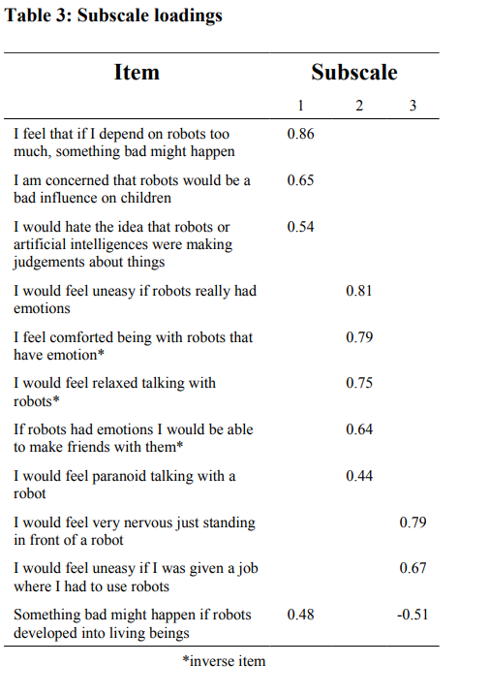

**Robots While Traveling**

An examination of consumer perceptions was conducted to assess the influences of consumer trust toward robots. Trust in information technology is defined as user's expectation that information technology artifacts such as websites, virtual peers, robots and similar devices and software will fulfill the expected responsibilities [17]. Negative perceptions contribute to the strength of this trust. Questionnaires were distributed to a wide range of residents in the United States. The residents participated in two studies to compensate for two aspects of traveling: transportation and entertainment. The first study [Fig.3] collected data on participant perceptions of an on-demand self-driving vehicle. The second study collected data from participant perceptions of a robot bartender [Fig. 5].

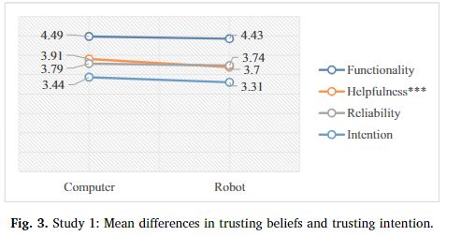

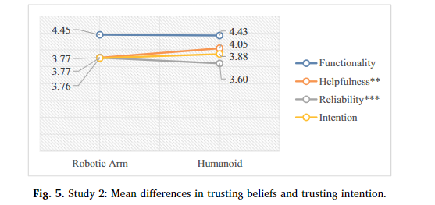

Summary and Conclusions

When participants were required to work with robots in a “living room” setting [15], it was found that overall NARS scores had little to no effect on the evaluations of the robot with more assertive and direct behaviors. Participants with a higher score on the NARS scale were less comfortable with the behaviors of the robot with a wider range of interaction sequences.

In the study that compared participant perceptions of robot interactions in the car versus with a robot bartender [17], the researchers found that the most significant contribution to the increased comfort of participants in proper preparation. Developers were encouraged to communicate the benefits of autonomous transportation and inform the public about the functionality of autonomous vehicles.

Both studies have shown that humans prefer robots that exhibit robotic behavior instead of human-like behavior. Participants are more inclined to trust a robot that clearly performs its tasks, instead of performing a wider range of tasks.

**METHODOLOGY**

For this paper, two journals examining participant perceptions toward robots using NARS were evaluated. Each journal used different methods of comparison for the actions of each robot. In the first study [15], participants interacted with Robot A, a more assertive and direct robot, and Robot B, a less assertive robot with a wider range of action sequences. Twenty-eight participants (14 male and 14 female) between the ages of 18-55 were asked to take part in a simulated “living room” to complete a task in a shared space with a robot. Participants were given questionnaires after each interaction with each robot. This information was compiled and used the Principal Components Analysis to develop a comprehensive result.

In the second study [17], a questionnaire was mass distributed through Amazon Mechanical Turk to all residents of the United States in reference to perceptions of robots in vehicles and bars. Those who failed to answer these questions correctly (less than 10% of survey takers for both studies) were removed from the dataset. A two-step approach was used to analyze the data. The first step was to start with confirmatory factor analysis to test the adequacy of the measurement model, followed by a structural equation model to test adequacy of the structural model for hypotheses testing.

Limitations

The database used for this study was Google Scholar. This is due to the plethora of available research studies in the topic of HCI. Science Direct was also used. Other databases could have been used to provide a wider source of information.

Both journals evaluated in this suggested that the constructs within NARS may not be applied in different contexts, especially in situations involving

participants with different cultural backgrounds.

**DISCUSSION, RECOMMENDATIONS, and CONCLUSIONS**

Discussion

The participant preference to less human-like robots may be due to the human inclination to categorize. Blurring the lines of human and robot behavior, appearance, and mannerisms may be overwhelming to many people. Humans prefer to be able to clearly distinguish a robot from a traditional living thing. Negative perceptions can also be alleviated if developers provide sufficient information to those interacting with robots. This preparation coupled with the clear intentions or tasks of the robot will likely aid in increased comfort level of people in their interactions with robots.

Recommendations

This research may be used to explore student perceptions of a robot teachers. The study can be based on using NAO humanoid robot, Ms. An (Meeting Students Academic Needs) as a Socially Adaptive Robot Tutor. Our research focuses on gauging students’ perceptions of a robot tutor and understanding the factors that could lead to negative perceptions. In the study, Ms. An will give a scenario describing an image that will be displayed and students will be tested on the details of the image. We will conduct this study with sixty participants. Thirty of which will be in the control condition where they will be given a short lesson with correct information. The other 30 will be in the condition where they will be given a lesson with incorrect information. We expect participants to report positive attitudes and perceptions of Ms. An. In the case where Ms. An will give a wrong description of an image to the students, it is expected that the students will trust and follow the robot’s description-trusting that the robot is telling an accurate story. The perceptions of the students will be measured using the Robot Persona Inventory (RPI) and questionnaire from the study.

Participants

The participants can include 60 college students ranging from a bout 18-22 years of age. Students are expected to be recruited from Claflin University in Orangeburg, South Carolina. Approximately 90% of the students are Black or African American that are enrolled at Claflin.

Materials

Robot Platform. The NAO robot stands 58 cm tall. It is equipped with 25 degrees of movement, 2 cameras, multiple touch sensors, and 4 microphones. The robot also has voice recognition, text to speech functionality,

and vision recognition. The NAO is ideal for research and educational purposes because of its many features and capabilities.

Social Characteristics of Ms. An.

A robots personality is a key factor in how a human with trust and accept it. Different features can be presented on robotic models to display social characteristics.

Electronic Workbook. Students are expected to take the questionnaire, pre-test, lesson, post-test, and robot persona inventory on a desktop computer. Some questions are fill in the blank, some are multiple choice, and a few are true or false.

Demographic Questionnaire. Students will take a simple demographic questionnaire that will briefly describe the study sample.

Procedure

The lesson will be conducted in a closed class room in small groups. The researchers will be present in the room to observe the interaction and everything that goes on during each session. Participants will read and sign consent forms prior to participating in the study. Each session is expected to last about 30 minutes.

On laptops, participants will first take the demographic questionnaire. Answers are not required, but they are helpful for researchers to have a better understanding of their participants.

Next, students will take a pre-test. They will be presented with a picture in which they have to answer a few simply straight forward questions about.

Then, the will be taught a lesson. The robot will tell a story to them based on another picture. Some parts will be correct and others will be incorrect.

After the lesson, the participants will be given a post-test in which they will answer questions based on either what the robot told them or what they see for themselves. This is where trust in the robot will be tested.

Following the post-test, students will take a robot persona inventory. At this stage, they will be presented with statements like “The robot seemed knowledgeable” and “The robot was enthusiastic” and will answer based on how much they agree.

The study will conclude with a closing/ debriefing statement that the students will read and understand that the study is completed at this time.

Conclusions

In order to create a more harmonious relationship between humans and robots, humans must be the primary concern of the developer. As such, they are the primary consumers and users of such technology and should be given proper training and preparation to manage expectations and alleviate concerns. Technology will continue to advance and robots will continue to be incorporated into the lives of future generations. Just as a robot must be prepared to perform tasks and function with their specific purpose in homes, businesses, and schools, humans also need to be given proper preparation.

**REFERENCES**

**Appendix A: Title of Appendix**

1. M. Goodrich, A. Schultz. (2007). Human–Robot Interaction: A Survey. Vol. 1, No. 3 (2007) 203–275 (2007).
2. Han, J., Jo, M., Park, S., & Kim, S. (2005). The educational use of home robots for children. In Proceedings of the 14th IEEE International Workshop on Robot and Human Interactive Communication (RO-MAN 2005) (pp. 378–383). Piscataway, NJ: IEEE.
3. Han, J. (2012). Emerging technologies: Robot assisted language learning. Language Learning and Technology, 16(3), 1–9.
4. P. Robinette, A. M. Howard. (2012). Trust in Emergency Evacuation Robots. 2012 IEEE International Symposium on Safety, Security, and Rescue Robotics (SSRR).
5. Sharkey, A.J.C. Ethics Inf Technol (2016) 18: 283. https://doi.org/10.1007/s10676-016-9387-z
6. Liles, K.R. et al. Rural Minority Students’ Perceptions of Ms. An, The Robot Teaching Assistant, as a Social Teaching Tool (2016). Volume: 59 issue: 1, page(s): 372-376. https://doi.org/10.1177/1541931215591077
7. Baker, A. L., Phillips, E. K., Ullman, D., & Keebler, J. R. (2018). Toward an Understanding of Trust Repair in Human-Robot Interaction. ACM Transactions on Interactive Intelligent Systems, 8(4), 1–30. doi: 10.1145/3181671
8. Che, Y., Culbertson, H., Tang, C.-W., Aich, S., & Okamura, A. M. (2018). Facilitating Human-Mobile Robot Communication via Haptic Feedback and Gesture Teleoperation. ACM Transactions on Human-Robot Interaction, 7(3), 1–23. doi: 10.1145/3243503
9. Goodrich, M. A., & Schultz, A. C. (2007). Human-Robot Interaction: A Survey. doi: 10.1561/9781601980939
10. Sharkey, A. J. C. (2016). Should we welcome robot teachers? Ethics and Information Technology, 18(4), 283–297. doi: 10.1007/s10676-016-9387-z
11. Silva, A. F. F., Ferreira, M. E. D. A., Inacio, F. A. J., & Andrade, J. D. F. (2019). An Experience in Distance Robotics Education through an Extension Course. 2019 Latin American Robotics Symposium (LARS), 2019 Brazilian Symposium on Robotics (SBR) and 2019 Workshop on Robotics in Education (WRE). doi: 10.1109/lars-sbr-wre48964.2019.00077
12. Victal, E. R. D. N., & Candido, A. P. (2019). Learning Programming with Robotics Using Arduino: Practice and Interdisciplinarity. 2019 Latin American Robotics Symposium (LARS), 2019 Brazilian Symposium on Robotics (SBR) and 2019 Workshop on Robotics in Education (WRE). doi: 10.1109/lars-sbr-wre48964.2019.00094
13. Diana, F., Kawahara, M., Saccardi, I., Hortensius, R., Tanaka, A., &amp; Kret, M. (2022). A cross-cultural comparison on implicit and explicit attitudes towards artificial agents. doi:10.31234
14. Krägeloh, C. U., Bharatharaj, J., Sasthan Kutty, S. K., Nirmala, P. R., & Huang, L. (2019). Questionnaires to measure acceptability of Social Robots: A critical review. *Robotics*, *8*(4), 88. doi:10.3390
15. Syrdal. D.S., Dautenhahn, K., Koay, K.L., Walters, M.L. (2009). The Negative Attitudes Towards Robots Scale and reactions to robot behaviour in a live Human-Robot Interaction study
16. Nomura, T.; Sugimoto, K.; Syrdal, S.S.; Dautenhahn, K. Social acceptance of humanoid robots in Japan: A survey for development of the Frankenstein Syndorome Questionnaire. In Proceedings of the 12th IEEE-RAS International Conference on Humanoid Robots, Osaka, Japan, 29 November–1 December 2012; pp. 242–
17. Iis P. TussyadiahFlorian J. ZachJianxi Wang (2020). Do travelers trust intelligent service robots? Annals of Tourism Research 81 102886